|  |
| --- |
|  |
| VIRTUAL STOCK MARKET |
| A stock market simulator |
|  |
| **U.Sriram Koushik** |
| **10I349**  **B.Tech IT(G2)**  **9/7/2012** |

|  |
| --- |
|  |

**INTRODUCTION**

**What is a stock market simulator?**

* A stock market simulator is a simulating environment of the real stock exchange.
* A real stock exchange involves the riskiness of involving a large scale of money.
* But the simulator can allow the user to make investments and operations could be made with a help of virtual money
* A stock market simulator can simulate the profit that could be obtained while trading with shares.

**MODULES INVOLVED**

* Formulating a clear idea and collecting requirements
* Creating the database structure
* Coding phase
  + Login
  + Program the various operations involved
  + Connect with the database
  + Creating the admin area for testing and exclusive access to the database
  + Integrating the bot and the application
  + Create an exclusive GUI with various designs in mind
  + Security measures

**IMPLEMENTATION**

* The whole project has been divided into several files
  + **compcurr.php** A page to compute the current stock prices
  + **makeprop.php** A page where user makes a proposal for selling or buying
  + **mypage.php** The first page that is visibe to the user. Contains all the needs of the user.
  + **login.php** The login page for the system
  + **viewprop.php** This page shows the proposas that are awaiting the user
  + **delmybp.php** This page is used to delete the buying proposals made by the user
  + **delmysp.php** This page is used to delete the buying proposals made by the user
  + **delprop.php** This page is used to delete the proposals made by the user
  + **init.php** This is used to initialise the parameters of the system
  + **logout.php** This is a basic logout page from where the user is redirected to the login page
  + **psgstock.sql** The emported .sql file of the database

**Php files**

**login.php**

<?php

include('dbconnect.php');

?>

<html>

<head>

<title>

PSG STOCK EXCHANGE - LOGIN

</title>

<link rel="stylesheet" type="text/css" href="style.css">

</head>

<body bgcolor="#3162B0">

<font face="Verdana">

<div id="loginbox" style="padding:10px;width:310px;margin-top:15%;margin-left:38%;">

<br>

<form name="login" method="post" action="<?php echo $_SERVER['PHP_SELF']; ?>">

<table border="0">

<tr>

<td><b>&nbsp &nbspUsername : <b></td>

<td><input type="text" size="16" name="user"/></td>

</tr>

<tr>

<td><b>&nbsp &nbspPassword : </b></td>

<td><input type="password" size="8" name="pass"/></td>

</tr>

<tr>

<td></td>

<td><input type="submit" name="Submit" value=" LOGIN "></td>

</tr>

</table>

</form>

<font color="red" face="Verdana">

<?php

$check=0;

if (isset($_POST['Submit']))

{

$usern=$_POST['user'];

$passw=$_POST['pass'];

if($usern!=""&&$passw!="")

{

$query="SELECT password from login WHERE username='$usern'";

$result=mysql_query($query);

$num=mysql_numrows($result);

if($num==1)

{

if($passw==mysql_result($result,0,'password'))

{

setcookie("psgcookie", $usern);/*We could also set the expiry time i.e time()+3600 after a comma*/

header("Location: mypage.php");

}

else

echo "<br/>&nbsp &nbsp &nbsp &nbsp &nbsp &nbspCombination mismatch <br/>";

}

else

echo "<br/>&nbsp &nbsp &nbsp &nbsp &nbsp &nbspNo such user found <br/>";

}

else

{

echo "<br/>&nbsp &nbsp &nbspusername or password field is empty!<br/>";

}

}

?>

</font>

</div>

</font>

</body>

</html>

**MYPAGE.PHP**

<?php

include('dbconnect.php');

if($_COOKIE["psgcookie"]=="")

header("Location: login.php");

?>

<!DOCTYPE html PUBLIC "-//W3C//DTD XHTML 1.0 Strict//EN" "http://www.w3.org/TR/xhtml1/DTD/xhtml1-strict.dtd">

<html xmlns="http://www.w3.org/1999/xhtml">

<head>

<META HTTP-EQUIV="REFRESH" CONTENT="15"><!--Make the number suitable so as to refresh accordingly-->

<script type="text/javascript">

function showprice(str)

{

if (str=="")

{

document.getElementById("txtHint").innerHTML="";

return;

}

if (window.XMLHttpRequest)

{// code for IE7+, Firefox, Chrome, Opera, Safari

xmlhttp=new XMLHttpRequest();

}

xmlhttp.onreadystatechange=function()

{

if (xmlhttp.readyState==4 && xmlhttp.status==200)

{

document.getElementById("txtHint").innerHTML=xmlhttp.responseText;

}

}

xmlhttp.open("GET","getprice.php?q="+str,true);

xmlhttp.send();

}

</script>

<title>WELCOME TO PSG STOCK EXCHANGE</title>

<link rel="stylesheet" type="text/css" href="style.css" />

</head>

<body bgcolor="#825A64">

<div id="wrapper">

<div id="header">

<div id="viewprop">

<center><h2>&nbsp&nbsp<a href="viewprop2.php"><font size="2" color="#165182">VIEW/ACCEPT PROPOSALS</a>&nbsp&nbsp</font></h2></center>

</div>

<div id="buyprop">

<center><h2>&nbsp&nbsp<a href="makeprop.php" target="_new"><font size="2" color="#165182">MAKE A BUY/SELL PROPOSAL</a>&nbsp&nbsp</font></h2></center>

</div>

<div id="buyprop">

<center><h2>&nbsp&nbsp<a href="delprop.php" target="_new"><font size="2" color="#165182">DELETE PROPOSALS MADE BY ME</a>&nbsp&nbsp</font></h2></center>

</div>

<div id="initial">

<center><h2>&nbsp&nbsp<a href="compcurr.php" target="_new"><font size="2" color="#165182">CURRENT SHARE PRICES</font></a>&nbsp&nbsp</font></h2></center>

</div>

<div id="initial">

<center><h2>&nbsp&nbsp<a href="init.php" target="_new"><font size="2" color="#165182">BUY INITIAL STOCKS</font></a>&nbsp&nbsp</font></h2></center>

</div>

<div id="logout">

<center><h2><b><a href="logout.php"><font color="red">LOGOUT</font></a></b></h2></center>

</div>

</div>

<div id="leftcolumn">

<div id="leftcolumn2">

<?php

$user=$_COOKIE["psgcookie"];

$query1="SELECT *from howmuchshares INNER JOIN company ON howmuchshares.ccode=company.ccode where teamname='".$user."'";

$result1=mysql_query($query1);

if(!$result1)

echo mysql_error();

print '<table align=center width=100% border=1>';

print '<th>company</th>';

print '<th>no of shares</th>';

print '<th>value(Rs.)</th>';

while($row1=mysql_fetch_assoc($result1))

{

print '<tr width=430px>';

print '<td width=30% align=center>';

echo htmlspecialchars( stripslashes($row1["ccode"]));

print '</td>';

print '<td width=30% align=center>';

echo htmlspecialchars( stripslashes($row1["noshares"]));

print '</td>';

print '<td width=40% align=center>';

echo htmlspecialchars( stripslashes($row1["noshares"])*$row1["rate"]);

print '</td>';

print '</tr>';

}

print '</table>';

?>

</div>

<h2><font size=3">&nbsp &nbsp &nbsp &nbsp &nbsp &nbsp &nbsp &nbsp &nbsp &nbsp MY ACCOUNT</font></h2>

<br>

<br>

<?php

echo "<br/>";

$user=$_COOKIE["psgcookie"];

$query="SELECT * from teamdetails where teamname='".$user."'";

$result=mysql_query($query);

echo "&nbsp &nbspTEAM NAME : &nbsp &nbsp &nbsp &nbsp &nbsp &nbsp &nbsp &nbsp &nbsp";

echo mysql_result($result,0,'teamcompname');

echo "<br />";

echo "<br />";

echo "&nbsp &nbspTEAM USER ID : &nbsp &nbsp &nbsp &nbsp &nbsp &nbsp &nbsp";

echo mysql_result($result,0,'teamname');

echo "<br />";

echo "<br />";

echo "&nbsp &nbspTEAM NUMERICAL ID : &nbsp &nbsp";

echo mysql_result($result,0,'teamid');

echo "<br />";

echo "<br />";

echo "&nbsp &nbspCASH BALANCE : &nbsp &nbsp &nbsp &nbsp &nbsp &nbspRs.";

echo mysql_result($result,0,'cash');

echo "<br />";

echo "<br />";

echo "&nbsp &nbspNO OF TRANSACTIONS : ";

echo mysql_result($result,0,'nooftrans');

?>

<br>

<center><b>* This page refreshes itself every 30 seconds</b></center>

</div>

<div id="rightcolumn">

<center><h2><font size="3">CURRENT STOCK PRICES</font></h2></center>

<form action="">

<select name="customers" onchange="showprice(this.value)">

<option value="">Select a company</option>

<option value="baj">Bajaj Auto Limited</option>

<option value="bhel">Bharat Heavy Electricals Ltd.</option>

<option value="airt">Bharti Airtel Ltd.</option>

<option value="cipl">Cipla Ltd.</option>

<option value="coal">Coal India Ltd.</option>

<option value="dlf">Dlf Limited</option>

<option value="hdfc">Hdfc Bank Ltd</option>

<option value="hero">Hero Motocorp Ltd</option>

<option value="hind">Hindalco Industries Ltd</option>

<option value="huni">Hindustan Unilever Ltd.</option>

<option value="hodf">Housing Development Fin. Corpn</option>

<option value="icici">Icici Bank Ltd.</option>

<option value="infy">Infosys Ltd.</option>

<option value="itc">Itc Ltd.</option>

<option value="jai">Jaiprakash Associates Limited</option>

<option value="jsp">Jindal Steel & Powers Ltd.</option>

<option value="lt">Larsen & Toubro Ltd.</option>

<option value="mml">Mahindra & Mahindra Ltd</option>

<option value="maru">Maruti Suzuki India Limited</option>

<option value="ntpc">Ntpc Ltd.</option>

<option value="ongc">Ongc Corpn</option>

<option value="rel">Reliance Industries Ltd.</option>

<option value="wip">Wipro Ltd.</option>

<option value="sbi">State Bank Of India</option>

<option value="ster">Sterlite Industries.</option>

<option value="sun">Sun Pharmaceutical Inds Ltd.</option>

<option value="tcs">Tata Consultancy Services Limited </option>

<option value="tata">Tata Motors Ltd.</option>

<option value="tpc">Tata Power Co. Ltd. </option>

<option value="tsteel">Tata Steel Limited.</option>

</select>

</form>

<br />

<div id="txtHint"><b>The price of the share will be displayed here..</b></div>

<br>

<div id="requestf1">

<iframe src="makeprop.php" width="380px" height="350px"></iframe>

</div>

</div>

</div>

</body>

</html>

**COMPCURR.PHP**

<?php

include('dbconnect.php');

if($_COOKIE["psgcookie"]=="")

header("Location: login.php");

?>

<!DOCTYPE html PUBLIC "-//W3C//DTD XHTML 1.0 Strict//EN" "http://www.w3.org/TR/xhtml1/DTD/xhtml1-strict.dtd">

<html xmlns="http://www.w3.org/1999/xhtml">

<head> <!--CANNOT FIX THE INITIAL NUMBER OF SHARES FOR EACH COMPANY-->

<META HTTP-EQUIV="REFRESH" CONTENT="5"><!--Make the number suitable so as to refresh accordingly-->

<title>WELCOME TO PSG STOCK EXCHANGE</title>

<link rel="stylesheet" type="text/css" href="style.css" />

</head>

<body bgcolor="#825A64">

<div id="wrapper">

<div id="header">

<div id="buyprop">

<center><h2>&nbsp&nbsp<a href="mypage.php"><font size="2" color="#165182">MY PAGE</a>&nbsp&nbsp</font></h2></center>

</div>

<div id="viewprop">

<center><h2>&nbsp&nbsp<a href="viewprop2.php"><font size="2" color="#165182">VIEW/ACCEPT PROPOSALS</a>&nbsp&nbsp</font></h2></center>

</div>

<div id="buyprop">

<center><h2>&nbsp&nbsp<a href="makeprop.php"><font size="2" color="#165182">MAKE A BUY/SELL PROPOSAL</a>&nbsp&nbsp</font></h2></center>

</div>

</div>

</div>

<div id="cent">

<br>

<h2><center><b>CURRENT SHARE PRICES<b></center></h2>

<br>

<?php

$user=$_COOKIE["psgcookie"];

$query1="SELECT * from company where 1=1 ORDER BY cid ASC";

$result1=mysql_query($query1);

print '<table align=center width=100% border=1>';

print '<th>Company name</th>';

print '<th>Company ID</th>';

print '<th>Company code</th>';

print '<th>current price/share(Rs.)</th>';

print '<th>volume</th>';

while($row1=mysql_fetch_assoc($result1))

{

print '<tr width=80%>';

print '<td width=35% align=center>';

echo htmlspecialchars( stripslashes($row1["cname"]));

print '</td>';

print '<td width=10% align=center>';

echo htmlspecialchars( stripslashes($row1["cid"]));

print '</td>';

print '<td width=10% align=center>';

echo htmlspecialchars( stripslashes($row1["ccode"]));

print '</td>';

print '<td width=20% align=center>';

echo htmlspecialchars( stripslashes($row1["rate"]));

print '</td>';

print '<td width=20% align=center>';

echo htmlspecialchars( stripslashes($row1["volume"]));

print '</td>';

print '</tr>';

}

print '</table>';

?>

<br>

<br>

</div>

</body>

</html>

**MAKEPROP.PHP**

<?php

include('dbconnect.php');

if($_COOKIE["psgcookie"]=="")

header("Location: login.php");

error_reporting(0);

?>

<html>

<head>

<link rel="stylesheet" type="text/css" href="style.css" />

<title>

SUBMIT PROPOSAL

</title>

</head>

<body bgcolor="#BD9C8C">

<div id="wrapper">

<div id="header">

<div id="buyprop">

<center><h2>&nbsp&nbsp<a href="mypage.php"><font size="2" color="#165182">MY PAGE</a>&nbsp&nbsp</font></h2></center>

</div>

<div id="viewprop">

<center><h2>&nbsp&nbsp<a href="viewprop2.php"><font size="2" color="#165182">VIEW/ACCEPT PROPOSALS</a>&nbsp&nbsp</font></h2></center>

</div>

<div id="buyprop">

<center><h2>&nbsp&nbsp<a href="delprop.php"><font size="2" color="#165182">DELETE PROPOSALS MADE BY ME</a>&nbsp&nbsp</font></h2></center>

</div>

</div>

</div>

<center><h2>MAKE A PROPOSAL</h2></center>

<br>

<form name="prop" method="post" action="<?php echo $_SERVER['PHP_SELF']; ?>">

<table border="0">

<tr>

<td><b>&nbsp &nbspCOMPANY : <b></td>

<td width="20px"><select name="comp1"/>

<option value="">SELECT A COMPANY</option>

<option value="baj">Bajaj Auto Limited</option>

<option value="bhel">Bharat Heavy Electricals Ltd.</option>

<option value="airt">Bharti Airtel Ltd.</option>

<option value="cipl">Cipla Ltd.</option>

<option value="coal">Coal India Ltd.</option>

<option value="dlf">Dlf Limited</option>

<option value="hdfc">Hdfc Bank Ltd</option>

<option value="hero">Hero Motocorp Ltd</option>

<option value="hind">Hindalco Industries Ltd</option>

<option value="huni">Hindustan Unilever Ltd.</option>

<option value="hodf">Housing Development Fin. Corpn</option>

<option value="icici">Icici Bank Ltd.</option>

<option value="infy">Infosys Ltd.</option>

<option value="itc">Itc Ltd.</option>

<option value="jai">Jaiprakash Associates Limited</option>

<option value="jsp">Jindal Steel & Powers Ltd.</option>

<option value="lt">Larsen & Toubro Ltd.</option>

<option value="mml">Mahindra & Mahindra Ltd</option>

<option value="maru">Maruti Suzuki India Limited</option>

<option value="ntpc">Ntpc Ltd.</option>

<option value="ongc">Ongc Corpn</option>

<option value="rel">Reliance Industries Ltd.</option>

<option value="wip">Wipro Ltd.</option>

<option value="sbi">State Bank Of India</option>

<option value="ster">Sterlite Industries.</option>

<option value="sun">Sun Pharmaceutical Inds Ltd.</option>

<option value="tcs">Tata Consultancy Services Limited </option>

<option value="tata">Tata Motors Ltd.</option>

<option value="tpc">Tata Power Co. Ltd. </option>

<option value="tsteel">Tata Steel Limited.</option>

</td>

</tr>

<tr>

<td><b>&nbsp &nbsp DESIRED PRICE/SHARE: </b></td>

<td><input type="text" size="8" name="price"/></td>

</tr>

<tr>

<td><b>&nbsp &nbsp DESIRED NO. OF SHARES: </b></td>

<td><input type="text" size="8" name="noof"/></td>

</tr>

<tr>

<td><b>&nbsp &nbsp TYPE OF PROPOSAL</b></td>

<td><input type="radio" name="typeof" value="s"/>SELL<input type="radio" name="typeof" value="b"/>BUY</td>

</tr>

<tr>

<td></td>

<td><input type="submit" name="Submit" value="SUBMIT"></td>

</tr>

</table>

</form>

<?php

if (isset($_POST['Submit']))

{

$user=$_COOKIE["psgcookie"];

$comp=$_POST['comp1'];

$noofsh=$_POST['noof'];

$despr=$_POST['price'];

$query1="SELECT * from howmuchshares where teamname='".$user."' AND ccode='".$comp."'";

$result1=mysql_query($query1);

$query10="SELECT *from company where ccode='".$comp."'";

$result10=mysql_query($query10);

$curprice=mysql_result($result10,0,'rate');

$pointfi=(5/100)*$curprice;

$upper=$curprice+$pointfi;

$lower=$curprice-$pointfi;

if((($comp!=""&&$noofsh!="")&&$despr!="")&&$_POST['typeof']!="")

{

$res1=mysql_result($result1,0,'noshares');

if($_POST['typeof']=='b')

{

if($noofsh>0)

{

if($despr<=$curprice+$pointfi&&$despr>=$curprice-$pointfi)

{

$query2="INSERT INTO buyprop VALUES('".$user."','".$comp."','".$despr."','".$noofsh."',NULL)";

mysql_query($query2);

echo "<br />&nbsp&nbsp&nbsp&nbsp<font color='green' size='3'><b>Your BUY PROPOSAL has been posted</b></font>";

}

else

{

echo "<center><font color='red'><b>*Desired price of the share could only be 5% greater or lesser than the current share price<br /><br /><center><font color='blue'>5% of ".$comp." share price is :&nbsp &nbsp Rs.".$pointfi."</br>Select a range from Rs.".$lower." and Rs.".$upper." </font></center> </b></font></center>";

}

}

else

echo "&nbsp&nbsp<font color='red'><b>*Enter valid number of shares </b></font>";

}

else

{

if($noofsh>0) //short selling ....********

{

if($despr<=$curprice+$pointfi&&$despr>=$curprice-$pointfi)

{

$query3="INSERT INTO sellprop VALUES('".$user."','".$comp."','".$despr."','".$noofsh."',NULL)";

mysql_query($query3);

echo "<br />&nbsp&nbsp&nbsp&nbsp<font color='green' size='3'><b>Your SELL PROPOSAL has been posted</b></font>";

}

else

{

echo "<center><font color='red'><b>*Desired price of the share could only be 5% greater or lesser than the current share price<br /><br /><center><font color='blue'>5% of the selected company's share price is :&nbsp &nbsp Rs.".$pointfi." </br>Select a range from Rs.".$lower." and Rs.".$upper." </font></center> </b></font></center>";

}

}

else

echo "&nbsp&nbsp<font color='red'><b>*Enter valid number of shares</b></font>";

}

}

else

echo "&nbsp&nbsp&nbsp&nbsp&nbsp&nbsp&nbsp<font color='red'><b>*Enter values for all the fields</b></font>";

}

?>

<iframe src="compcurr.php" width="100%" height="350px"></iframe>

</body>

</html>

**DELPROP.PHP**

<?php

include('dbconnect.php');

if($_COOKIE["psgcookie"]=="")

header("Location: login.php");

?>

<!DOCTYPE html PUBLIC "-//W3C//DTD XHTML 1.0 Strict//EN" "http://www.w3.org/TR/xhtml1/DTD/xhtml1-strict.dtd">

<html xmlns="http://www.w3.org/1999/xhtml">

<head>

<META HTTP-EQUIV="REFRESH" CONTENT="3"><!--Make the number suitable so as to refresh accordingly-->

<meta http-equiv="Content-Type" content="text/html; charset=iso-8859-1" />

<script type="text/javascript">

function delmybp(x)

{

alert('You are about to delete a buy proposal');

if (x=="")

{

document.getElementById("txtHint").innerHTML="";

return;

}

if (window.XMLHttpRequest)

{// code for IE7+, Firefox, Chrome, Opera, Safari

xmlhttp=new XMLHttpRequest();

}

xmlhttp.onreadystatechange=function()

{

if (xmlhttp.readyState==4 && xmlhttp.status==200)

{

document.getElementById("txtHint").innerHTML=xmlhttp.responseText;

}

}

xmlhttp.open("GET","delmybp.php?a="+x,true);

xmlhttp.send();

}

</script>

<script type="text/javascript">

function delmysp(x)

{

alert('You are about to delete a sell proposal');

if (x=="")

{

document.getElementById("txtHint1").innerHTML="";

return;

}

if (window.XMLHttpRequest)

{// code for IE7+, Firefox, Chrome, Opera, Safari

xmlhttp=new XMLHttpRequest();

}

xmlhttp.onreadystatechange=function()

{

if (xmlhttp.readyState==4 && xmlhttp.status==200)

{

document.getElementById("txtHint1").innerHTML=xmlhttp.responseText;

}

}

xmlhttp.open("GET","delmysp.php?a="+x,true);

xmlhttp.send();

}

</script>

<title>MY PROPOSALS</title>

<link rel="stylesheet" type="text/css" href="style.css" />

</head>

<body bgcolor="#B54E68">

<div id="wrapper3">

<div id="header">

<div id="buyprop">

<center><h2>&nbsp&nbsp<a href="mypage.php"><font size="2" color="#165182">MY PAGE</a>&nbsp&nbsp</font></h2></center>

</div>

<div id="viewprop">

<center><h2>&nbsp&nbsp<a href="viewprop2.php"><font size="2" color="#165182">VIEW/ACCEPT PROPOSALS</a>&nbsp&nbsp</font></h2></center>

</div>

<div id="buyprop">

<center><h2>&nbsp&nbsp<a href="makeprop.php"><font size="2" color="#165182">MAKE A BUY/SELL PROPOSAL</a>&nbsp&nbsp</font></h2></center>

</div>

</div>

<div id="leftcolumn3">

<br><br>

<h2><center><b>SELL PROPOSALS MADE BY ME</b></center></h2>

<br>

<br>

<?php

$user=$_COOKIE["psgcookie"];

$query1="SELECT * from sellprop where sid='".$user."'";

$result1=mysql_query($query1);

$num=mysql_numrows($result1);

if($num!=0)

{

while($row=mysql_fetch_assoc($result1))

{

echo "<br />";

echo '&nbsp';

echo '&nbsp';

echo "&nbsp<b>COMPANY NAME:</b>&nbsp&nbsp";

echo $row['ccode'];

echo "<br />";

echo '&nbsp';

echo '&nbsp';

echo "&nbsp<b>PROPOSED RATE:</b>&nbsp&nbsp";

echo $row['rate'];

echo "<br />";

echo '&nbsp';

echo '&nbsp';

echo "&nbsp<b>PROPOSED QUANTITY:</b>&nbsp&nbsp";

echo $row['qty'];

echo "<br />";

echo '&nbsp';

echo '&nbsp';

echo "&nbsp<b>PROPOSAL ID:</b>&nbsp&nbsp";

echo $row['propid'];

echo "<br />";

echo "<a href=javascript:void(0);' onclick='delmysp(".$row['propid'].");'><font color='red'><b>&nbsp&nbsp&nbspDELETE</b></font></a>";

echo "<div id='txtHint1'><b></b></div>";

echo "<br /><br />";

}

}

else

echo "<center><b>SORRY THERE ARE NO PROPOSALS CURRENTLY</b></center>";

?>

</div>

<div id="rightcolumn3">

<br><br>

<h2><center><b>BUY PROPOSALS MADE BY ME</b></center></h2>

<br>

<br>

<?php

$query11="SELECT * from buyprop where bid='".$user."'";

$result11=mysql_query($query11);

$num1=mysql_numrows($result11);

if($num1!=0)

{

while($row=mysql_fetch_assoc($result11))

{

echo "<br />";

echo '&nbsp';

echo '&nbsp';

echo "&nbsp<b>COMPANY NAME:</b>&nbsp&nbsp";

echo $row['ccode'];

echo "<br />";

echo '&nbsp';

echo '&nbsp';

echo "&nbsp<b>PROPOSED RATE:</b>&nbsp&nbsp";

echo $row['rate'];

echo "<br />";

echo '&nbsp';

echo '&nbsp';

echo "&nbsp<b>PROPOSED QUANTITY:</b>&nbsp&nbsp";

echo $row['qty'];

echo "<br />";

echo '&nbsp';

echo '&nbsp';

echo "&nbsp<b>PROPOSAL ID:</b>";

echo $row['propid'];

echo "<br />";

echo "<a href=javascript:void(0);' onclick='delmybp(".$row['propid'].");'><font color='red'><b>&nbsp&nbsp&nbspDELETE</b></font></a>";

echo "<div id='txtHint'><b></b></div>";

echo "<br /><br />";

}

}

else

echo "<center><b>SORRY THERE ARE NO PROPOSALS CURRENTLY</b></center>";

?>

</div>

</div>

</body>

</html>

**LOGOUT.PHP**

<?php

// set the expiration date as required.. Here we take it to a point where the psgcookie is not set

setcookie ("psgcookie", "", time() - 13000);

header("Location: login.php");

?>

**VIEWPROP.PHP**

<?php

include('dbconnect.php');

if($_COOKIE["psgcookie"]=="")

header("Location: login.php");

?>

<!DOCTYPE html PUBLIC "-//W3C//DTD XHTML 1.0 Strict//EN" "http://www.w3.org/TR/xhtml1/DTD/xhtml1-strict.dtd">

<html xmlns="http://www.w3.org/1999/xhtml">

<head>

<META HTTP-EQUIV="REFRESH" CONTENT="150"><!--Make the number suitable so as to refresh accordingly-->

<meta http-equiv="Content-Type" content="text/html; charset=iso-8859-1" />

<title>VIEW PROPOSALS</title>

<link rel="stylesheet" type="text/css" href="style.css" />

</head>

<body bgcolor="#B54E68">

<div id="wrapper3">

<div id="header">

<div id="viewprop">

<center><h2>&nbsp&nbsp<a href="mypage.php"><font size="2" color="#165182">MY PAGE</a>&nbsp&nbsp</font></h2></center>

</div>

<div id="buyprop">

<center><h2>&nbsp&nbsp<a href="makeprop.php"><font size="2" color="#165182">MAKE A BUY/SELL PROPOSAL</a>&nbsp&nbsp</font></h2></center>

</div>

<div id="buyprop">

<center><h2>&nbsp&nbsp<a href="delprop.php"><font size="2" color="#165182">DELETE PROPOSALS MADE BY ME</a>&nbsp&nbsp</font></h2></center>

</div>

</div>

<div id="leftcolumn3">

<div id="form1">

<center><b><h4>SELL PROPOSAL ACCEPTANCE FORM</h4></b></center>

<br>

<form name="acceptsell" method="post" action="<?php echo $_SERVER['PHP_SELF']; ?>">

<table width="100%">

<tr><td width="50%">PROPOSAL ID :</td>

<td width="30%"><input type="text" name="id"></td>

</tr>

<tr><td width="50%">QUANTITY ACCEPTED :</td>

<td width="30%"><input type="text" name="qtya"></td>

</tr>

<tr>

<td></td>

<td><input type="submit" name="Submit" value="ACCEPT"></td>

<tr>

</table>

</form>

<?php

$user=$_COOKIE["psgcookie"];

if(isset($_POST['Submit']))

{

$id=$_POST['id'];

$qtya=$_POST['qtya'];//quantity accepted

if($id!=""&&$qtya!="")

{ $query1="SELECT * from sellprop where propid='".$id."'";

$result1=mysql_query($query1);if(!mysql_query($query1))echo mysql_error();

$num1=mysql_numrows($result1);

if($num1==1)

{

$sid=mysql_result($result1,0,'sid');

$actqty=mysql_result($result1,0,'qty');

$transrate=mysql_result($result1,0,'rate');

$cid=mysql_result($result1,0,'ccode');

if($qtya==$actqty)

{

$query2="UPDATE company SET rate='".$transrate."' where ccode='".$cid."'";

mysql_query($query2);

$query3="UPDATE company SET volume=volume+'".$qtya."' where ccode='".$cid."'";

mysql_query($query3);

$tax=50+((0.5/100)*$qtya*$transrate);

echo "'".$tax."' -> SERVICE CHARGE";

$query4="UPDATE howmuchshares set noshares=noshares+'".$qtya."' where teamname='".$user."' AND ccode='".$cid."'";

$result4=mysql_query($query4);

$query5="UPDATE teamdetails set cash=(cash-('".$qtya."'*'".$transrate."'))-'".$tax."' where teamname='".$user."'";

mysql_query($query5);

$query6="UPDATE teamdetails set nooftrans=nooftrans+1 where teamname='".$user."'";

mysql_query($query6);

$query7="UPDATE teamdetails set cash=(cash+('".$qtya."'*'".$transrate."'))-'".$tax."' where teamname='".$sid."'";

mysql_query($query7);

$query8="UPDATE teamdetails set nooftrans=nooftrans+1 where teamname='".$sid."'";

mysql_query($query8);

$query9="UPDATE howmuchshares set noshares=noshares-'".$qtya."' where teamname='".$sid."' AND ccode='".$cid."'";

mysql_query($query9);

$query10="DELETE from sellprop where propid='".$id."'";

mysql_query($query10);

$t= date("d/m/y : H:i:s", time());

$query11="INSERT INTO transaction VALUES(NULL,'".$user."','".$sid."','".$transrate."','".$qtya."','".$t."') ";

mysql_query($query11);

echo "<br><center><font color='green'>Your transaction was successful!</font></center></br>";

}

else if($qtya<$actqty)

{

$query2="UPDATE company SET rate='".$transrate."' where ccode='".$cid."'";

mysql_query($query2);

$query3="UPDATE company SET volume=volume+'".$qtya."' where ccode='".$cid."'";

mysql_query($query3);

$tax=50+((0.5/100)*$qtya);

echo "'".$tax."' -> SERVICE CHARGE";

$query4="UPDATE howmuchshares set noshares=noshares+'".$qtya."' where teamname='".$user."' AND ccode='".$cid."'";

$result4=mysql_query($query4);

$query5="UPDATE teamdetails set cash=(cash-('".$qtya."'*'".$transrate."'))-'".$tax."' where teamname='".$user."'";

mysql_query($query5);

$query6="UPDATE teamdetails set nooftrans=nooftrans+1 where teamname='".$user."'";

mysql_query($query6);

$query7="UPDATE teamdetails set cash=(cash+('".$qtya."'*'".$transrate."'))-'".$tax."' where teamname='".$sid."'";

mysql_query($query7);

$query8="UPDATE teamdetails set nooftrans=nooftrans+1 where teamname='".$sid."'";

mysql_query($query8);

$query9="UPDATE howmuchshares set noshares=noshares-'".$qtya."' where teamname='".$sid."' AND ccode='".$cid."'";

mysql_query($query9);

$query10="UPDATE sellprop SET qty=qty-'".$qtya."' where propid='".$id."'";

mysql_query($query10);

$t= date("d/m/y : H:i:s", time());

$query11="INSERT INTO transaction VALUES(NULL,'".$user."','".$sid."','".$transrate."','".$qtya."','".$t."') ";

mysql_query($query11);

echo "<br><center><font color='green'>Your transaction was successful!</font></center></br>";

}

else

echo "<br><center><font color='red'>Maximum number of shares that you can accept is the quantity proposed</font></center></br>";

}

else

echo "<br><center><font color='red'>Enter valid proposal ID</font></center></br>";

}

else

echo"<br><center><font color='red'>Enter values for both the fields</font></center></br>";

}

?>

</div>

<br><br>

<h2><center><b>AVAILABLE SELLERS</b></center></h2>

<br>

<br>

<?php

$user=$_COOKIE["psgcookie"];

$query1="SELECT * from sellprop where 1=1 ORDER BY rate ASC ";

$result1=mysql_query($query1);

$num=mysql_numrows($result1);

if($num!=0)

{

while($row=mysql_fetch_assoc($result1))

{

if($user!=$row['sid'])

{echo '&nbsp';

echo '&nbsp';

echo "&nbsp<b>TEAM NAME:</b>&nbsp&nbsp";

echo $row['sid'];

echo "<br />";

echo '&nbsp';

echo '&nbsp';

echo "&nbsp<b>COMPANY NAME:</b>&nbsp&nbsp";

echo $row['ccode'];

echo "<br />";

echo '&nbsp';

echo '&nbsp';

echo "&nbsp<b>PROPOSED RATE:</b>&nbsp&nbsp";

echo $row['rate'];

echo "<br />";

echo '&nbsp';

echo '&nbsp';

echo "&nbsp<b>PROPOSED QUANTITY:</b>&nbsp&nbsp";

echo $row['qty'];

echo "<br />";

echo '&nbsp';

echo '&nbsp';

echo "&nbsp<b>PROPOSAL ID:</b>&nbsp&nbsp";

echo $row['propid'];

echo "<br />";

echo '&nbsp';

echo '&nbsp';

echo "&nbsp<b>YOU NEED:</b>&nbsp&nbspRs."; /*HAVE THIS IF NEEDED*/

echo $row['qty']*$row['rate'];

echo "<br />";

echo "<br />";

echo "<br />";

}

}

}

else

echo "<center><b>SORRY THERE ARE NO PROPOSALS CURRENTLY</b></center>";

?>

</div>

<div id="rightcolumn3">

<div id="form1">

<center><b><h4> BUY PROPOSAL ACCEPTANCE FORM</h4></b></center>

<br>

<form name="acceptbuy" method="post" action="<?php echo $_SERVER['PHP_SELF']; ?>">

<table width="100%">

<tr><td width="50%">PROPOSAL ID :</td>

<td width="30%"><input type="text" name="idb"></td>

</tr>

<tr><td width="50%">QUANTITY ACCEPTED :</td>

<td width="30%"><input type="text" name="qtyab"></td>

</tr>

<tr>

<td></td>

<td><input type="submit" name="Submit1" value="ACCEPT"></td>

<tr>

</table>

</form>

<?php

$user=$_COOKIE["psgcookie"];

if(isset($_POST['Submit1']))

{

$id=$_POST['idb'];

$qtya=$_POST['qtyab'];//quantity accepted

if($id!=""&&$qtya!="")

{ $query1="SELECT * from buyprop where propid='".$id."'";

$result1=mysql_query($query1);if(!mysql_query($query1))echo mysql_error();

$num1=mysql_numrows($result1);

if($num1==1)

{

$bid=mysql_result($result1,0,'bid');

$actqty=mysql_result($result1,0,'qty');

$transrate=mysql_result($result1,0,'rate');

$cid=mysql_result($result1,0,'ccode');

if($qtya==$actqty)

{

$query2="UPDATE company SET rate='".$transrate."' where ccode='".$cid."'";

mysql_query($query2);

$query3="UPDATE company SET volume=volume+'".$qtya."' where ccode='".$cid."'";

mysql_query($query3);

$tax=50+((0.5/100)*$qtya*$transrate);

echo "'".$tax."' -> SERVICE CHARGE";

$query4="UPDATE howmuchshares set noshares=noshares-'".$qtya."' where teamname='".$user."' AND ccode='".$cid."'";

$result4=mysql_query($query4);

$query5="UPDATE teamdetails set cash=(cash+('".$qtya."'*'".$transrate."'))-'".$tax."' where teamname='".$user."'";

mysql_query($query5);

$query6="UPDATE teamdetails set nooftrans=nooftrans+1 where teamname='".$user."'";

mysql_query($query6);

$query7="UPDATE teamdetails set cash=(cash-('".$qtya."'*'".$transrate."'))-'".$tax."' where teamname='".$bid."'";

mysql_query($query7);

$query8="UPDATE teamdetails set nooftrans=nooftrans+1 where teamname='".$bid."'";

mysql_query($query8);

$query9="UPDATE howmuchshares set noshares=noshares+'".$qtya."' where teamname='".$bid."' AND ccode='".$cid."'";

mysql_query($query9);

$query10="DELETE from buyprop where propid='".$id."'";

mysql_query($query10);

$t= date("d/m/y : H:i:s", time());

$query11="INSERT INTO transaction VALUES(NULL,'".$bid."','".$user."','".$transrate."','".$qtya."','".$t."') ";

mysql_query($query11);

echo "<br><center><font color='green'>Your transaction was successful!</font></center></br>";

}

else if($qtya<$actqty)

{

$query2="UPDATE company SET rate='".$transrate."' where ccode='".$cid."'";

mysql_query($query2);

$query3="UPDATE company SET volume=volume+'".$qtya."' where ccode='".$cid."'";

mysql_query($query3);

$tax=50+((0.5/100)*$qtya*$transrate);

echo "'".$tax."' -> SERVICE CHARGE";

$query4="UPDATE howmuchshares set noshares=noshares-'".$qtya."' where teamname='".$user."' AND ccode='".$cid."'";

$result4=mysql_query($query4);

$query5="UPDATE teamdetails set cash=(cash+('".$qtya."'*'".$transrate."'))-'".$tax."' where teamname='".$user."'";

mysql_query($query5);

$query6="UPDATE teamdetails set nooftrans=nooftrans+1 where teamname='".$user."'";

mysql_query($query6);

$query7="UPDATE teamdetails set cash=(cash-('".$qtya."'*'".$transrate."'))-'".$tax."' where teamname='".$bid."'";

mysql_query($query7);

$query8="UPDATE teamdetails set nooftrans=nooftrans+1 where teamname='".$bid."'";

mysql_query($query8);

$query9="UPDATE howmuchshares set noshares=noshares+'".$qtya."' where teamname='".$bid."' AND ccode='".$cid."'";

mysql_query($query9);

$query10="UPDATE buyprop SET qty=qty-'".$qtya."' where propid='".$id."'";

mysql_query($query10);

$t= date("d/m/y : H:i:s", time());

$query11="INSERT INTO transaction VALUES(NULL,'".$bid."','".$user."','".$transrate."','".$qtya."','".$t."') ";

mysql_query($query11);

echo "<br><center><font color='green'>Your transaction was successful!</font></center></br>";

}

else

echo "<br><center><font color='red'>Maximum number of shares that you can accept is the quantity proposed</font></center></br>";

}

else

echo "<br><center><font color='red'>Enter valid proposal ID</font></center></br>";

}

else

echo"<br><center><font color='red'>Enter values for both the fields</font></center></br>";

}

?>

</div>

<br><br>

<h2><center><b>AVAILABLE TAKERS</b></center></h2>

<br>

<br>

<?php

$query11="SELECT * from buyprop where 1=1 ORDER BY rate DESC";

$result11=mysql_query($query11);

$num1=mysql_numrows($result11);

if($num1!=0)

{

while($row=mysql_fetch_assoc($result11))

{

if($user!=$row['bid'])

{echo '&nbsp';

echo '&nbsp';

echo "&nbsp<b>TEAM NAME:</b>&nbsp&nbsp";

echo $row['bid'];

echo "<br />";

echo '&nbsp';

echo '&nbsp';

echo "&nbsp<b>COMPANY NAME:</b>&nbsp&nbsp";

echo $row['ccode'];

echo "<br />";

echo '&nbsp';

echo '&nbsp';

echo "&nbsp<b>PROPOSED RATE:</b>&nbsp&nbsp";

echo $row['rate'];

echo "<br />";

echo '&nbsp';

echo "&nbsp<b>PROPOSED QUANTITY:</b>&nbsp&nbsp";

echo $row['qty'];

echo "<br />";

echo "<br />";

}

}

}

else

echo "<center><b>SORRY THERE ARE NO PROPOSALS CURRENTLY</b></center>";

?>

</div>

</div>

</body>

</html>

**SCREEN SHOTS**

**LOGIN.PHP**

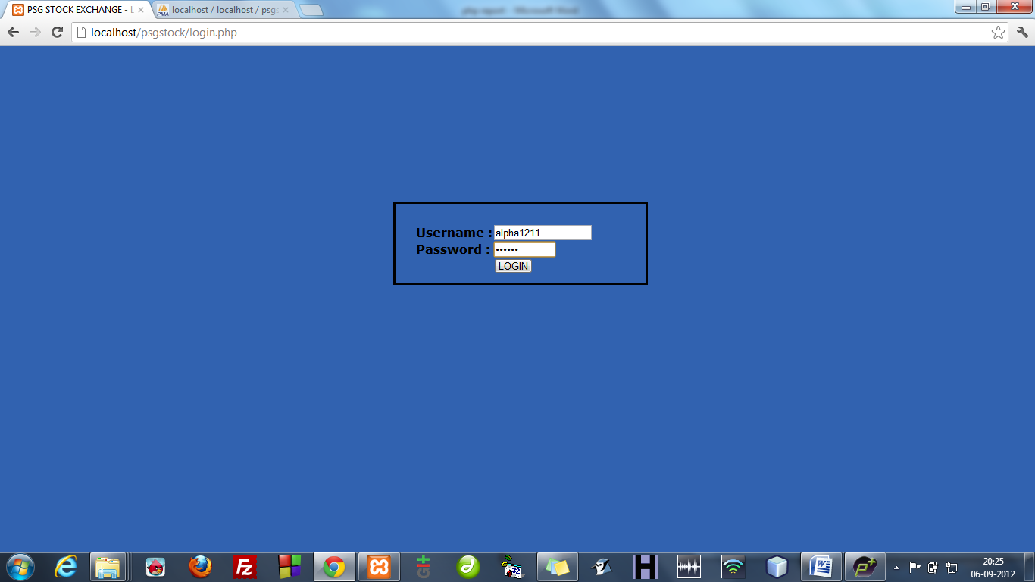

**MYPAGE.PHP**

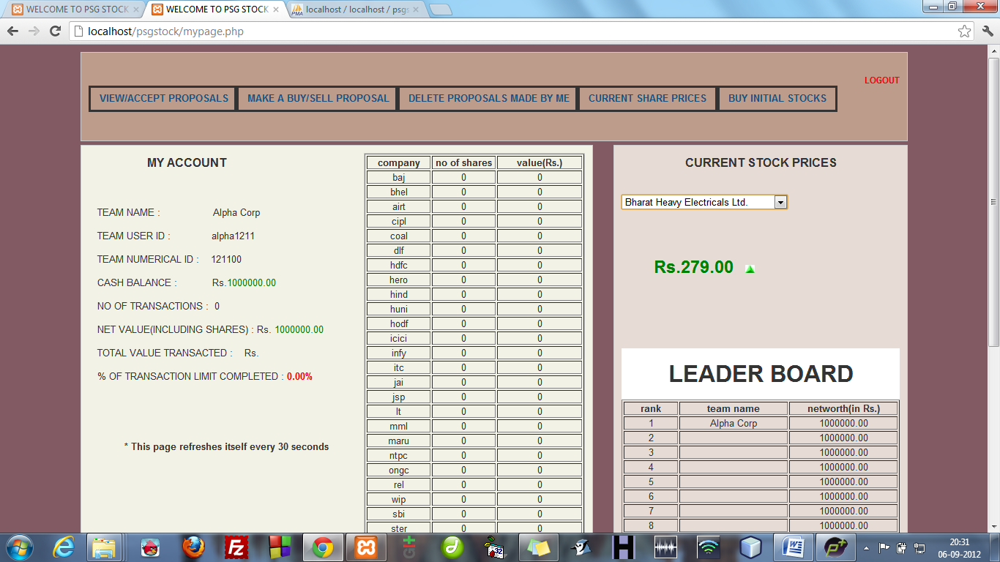

**VIEWPROP.PHP**

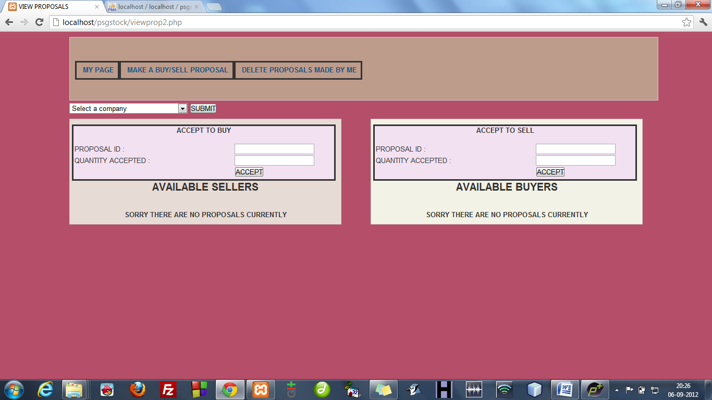

**MAKEPROP.PHP**

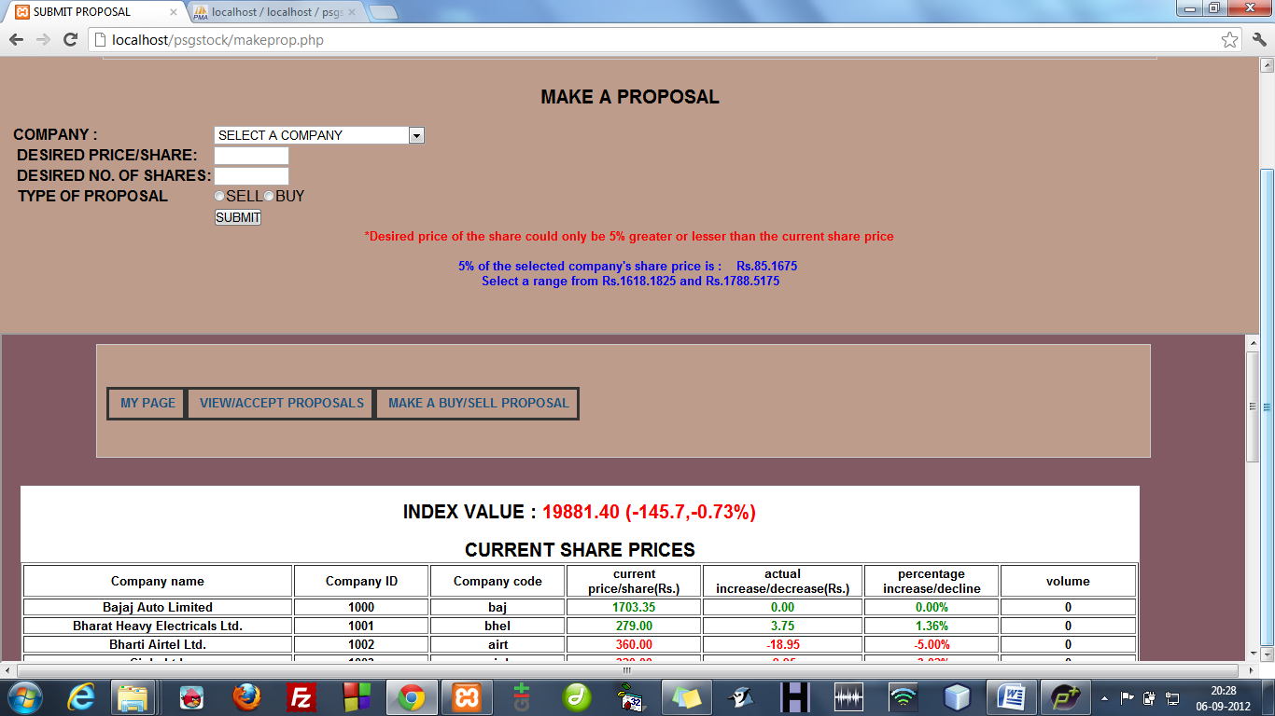

**MAKEPROP.PHP**

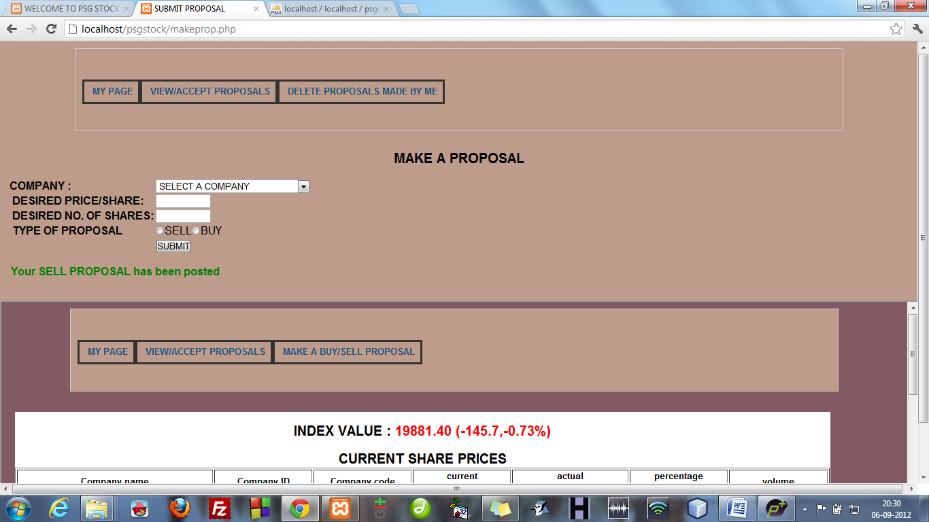

**COMPCURR.PHP**

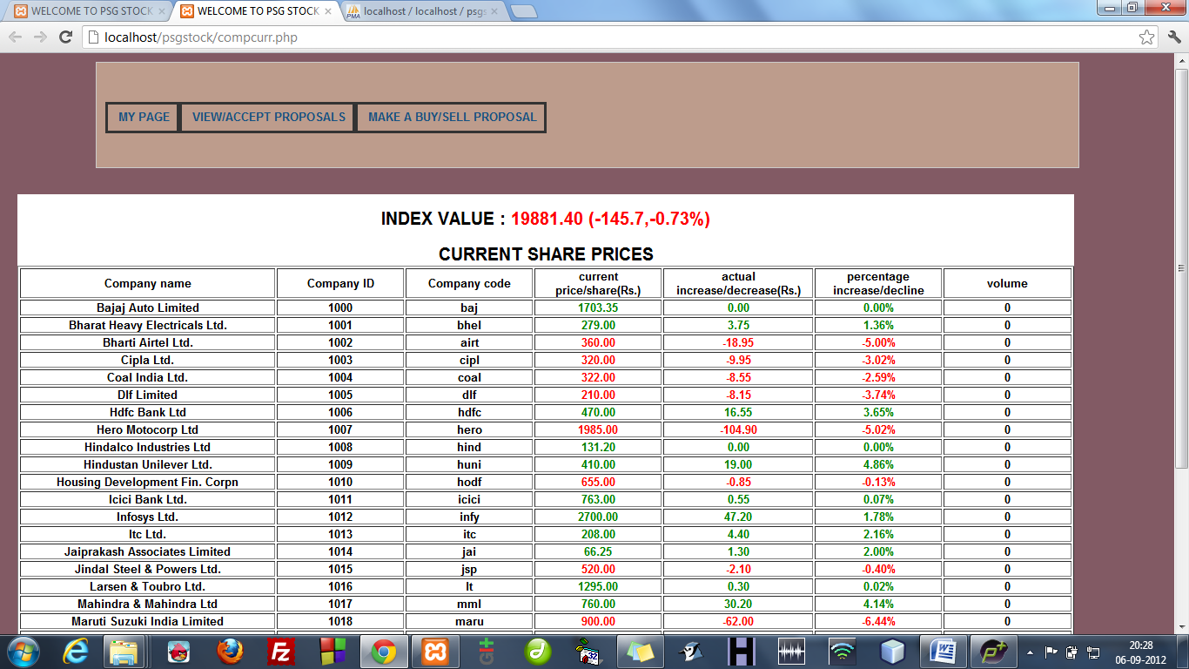

**DELPROP.PHP**

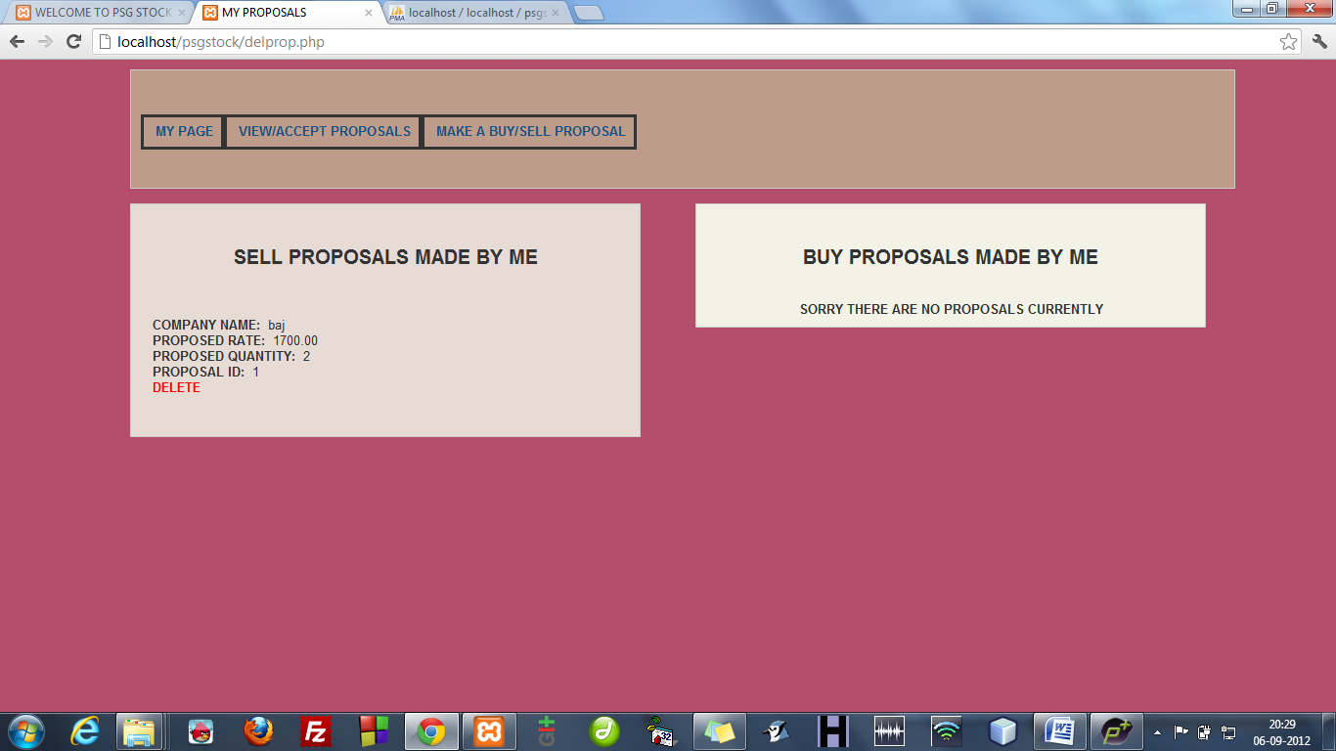

**INIT.PHP**

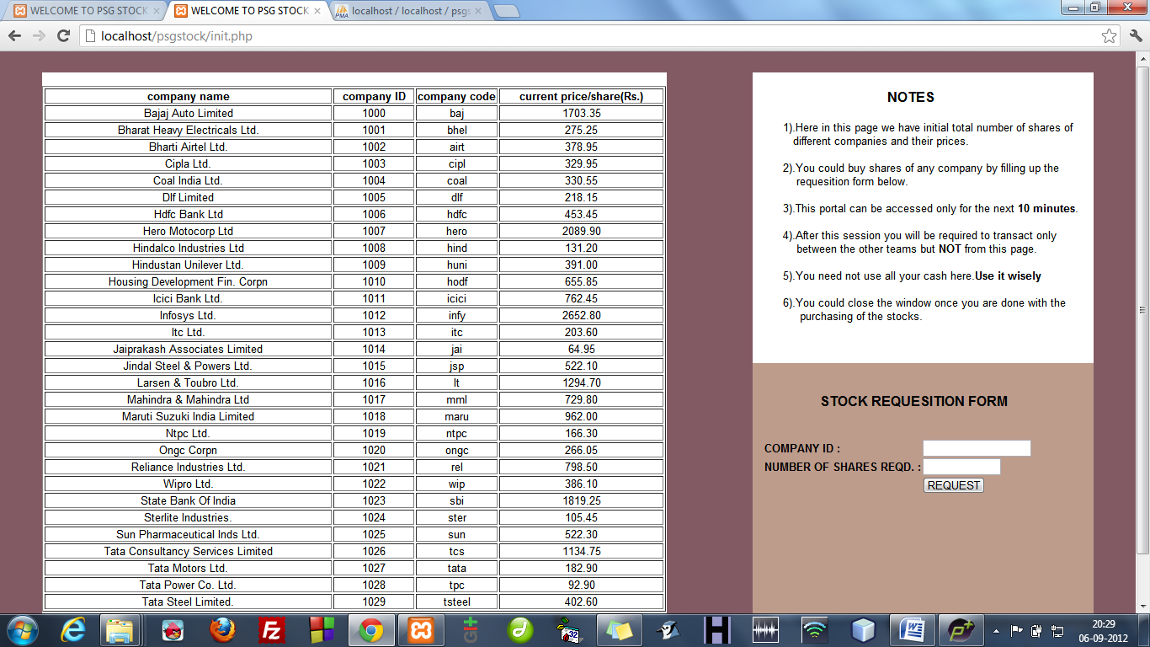

**DATABASE STRUCTURE**

**(XAMPP)**

